**What is Express JS and why do we need it?**

**Ans:** Express is a fast, assertive, essential and moderate web framework of Node.js. You can assume express as a layer built on the top of the Node.js that helps manage a server and routes. It provides a robust set of features to develop web and mobile applications.

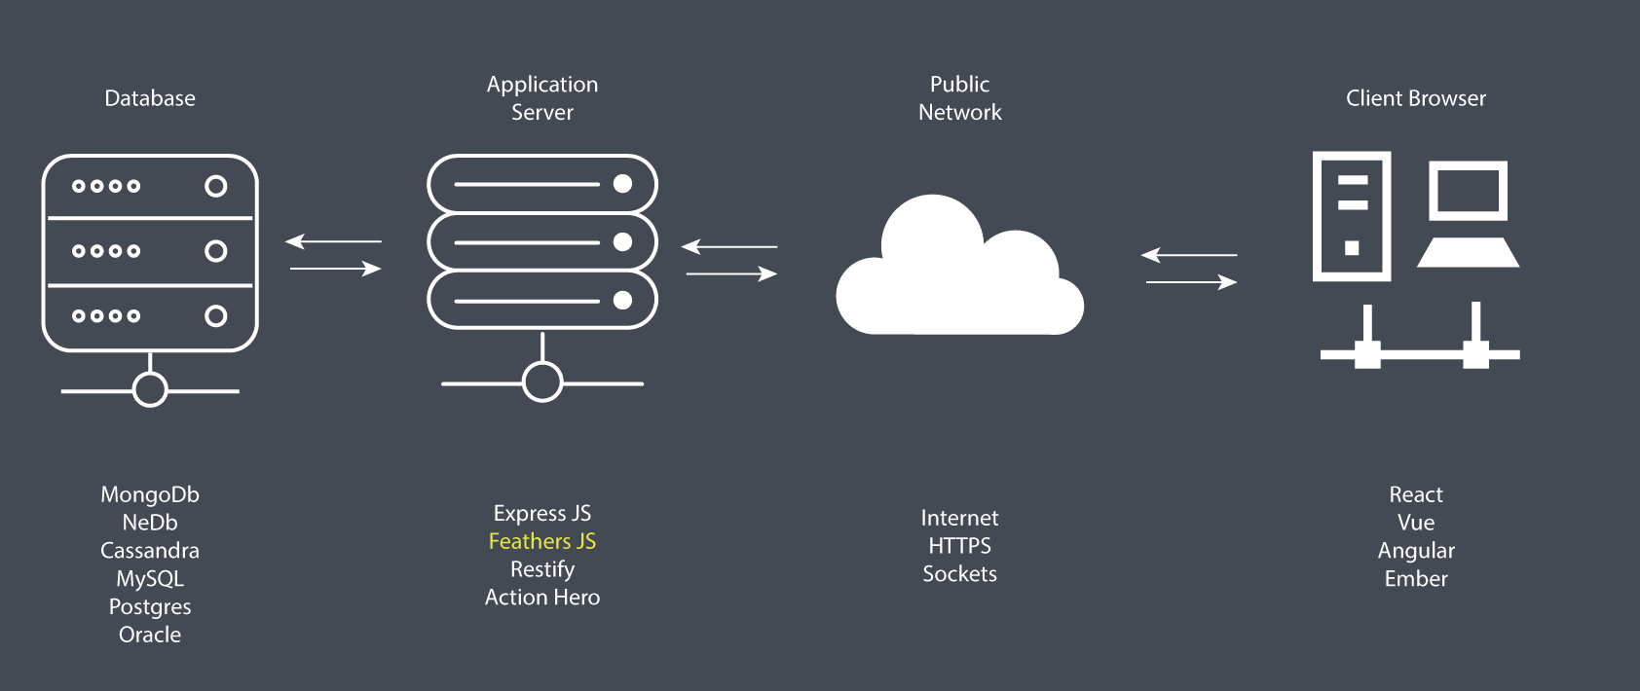

1. Go to the project directory and open the cmd.
2. Type : **npm install express –save**
3. Once the package is installed, you can check the list of packagess inside the **‘package.json’** file.
4. Also for easement of work, install NODEMON from terminal by typing: **npm i --g nodemon**
5. Then every time you want to run the project, just once type: **nodemon serve**